Monte Carlo MAP 5615 HW1

Sen Zhang

1

1. The LCG can only produce at most m distinct values. If (a, m) = 1, the maximum number of distinct values should be m.
2. If (a, m) = d, $\left(\frac{a}{d}, \frac{m}{d}\right)=1$. Thus the maximum number of distinct values is $\frac{m}{d}$.

To make the period of LCG as large as possible, it is better to choose (a, m) = 1

3

$$x_{n+1}=ax_{n}+c \left(mod m\right)$$

$$⇒x_{n+2}=a\left(ax_{n}+c\right)+c \left(mod m\right)=a^{2}x_{n}+\left(a+1\right)c (mod m)$$

$${⇒x}_{n+3}=a^{3}x_{n}+\left(a^{2}+a+1\right)c \left(mod m\right)$$

$⇒⋯$

$${⇒x}_{n+k}=a^{k}x_{n}+\left(a^{k}+⋯a+1\right)c (mod m)$$

$$⇒x_{n+k}≡a^{k}x_{n}+\frac{a^{k}-1}{a-1}c \left(mod m\right);(a≥2, k≥0)$$

6

$x_{1000}=649091873$

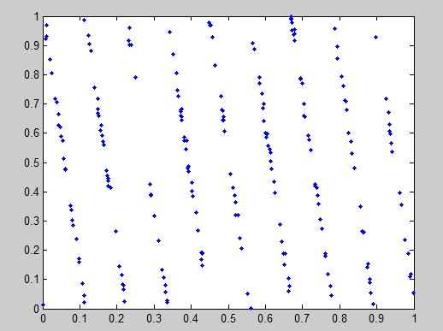

We already know $u_{i+2}-6u_{i+1}+9u_{i}=k$.

To plot $u_{i+2} versus u_{i}, we have u_{i+2}+9u_{i}=k$, where $0<u_{i}<1.$

Then 0<k<10, and thus the pairs must lie on no more than 9 lines on $R^{2}.$

1. 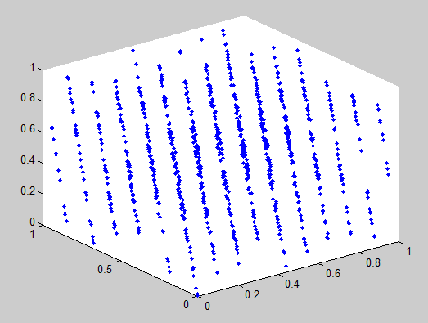

From the graph we can see there are 15 planes.

7

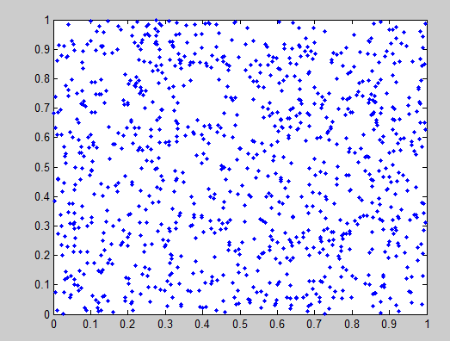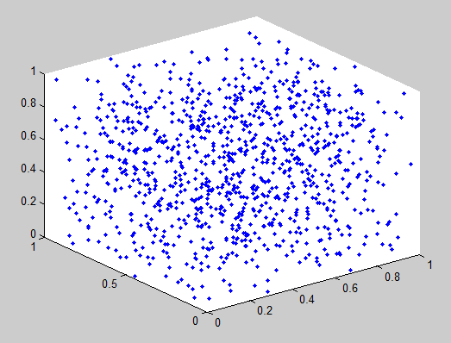

In the graph of pairs and triples there is no regular order. Mersenne twister provides for generation of high quality pseudorandom numbers.

Appendix

Code for problem 6

function I=RANDU(x0,N)

x=[];

x(1)=x0;

for i = 2:N;

x(i)= mod(65539\*x(i-1), 2^31);

end

I=x;

u=x/2^31;

%for i = 2:20003;

% if u(i+1)<=0.51 && u(i+1)>=0.5;

%plot(u(i), u(i+2), '.');

%hold on

%end

%end

u1=u(1:1000);

u2=u(2:1001);

u3=u(3:1002);

plot3(u1,u2,u3, '.');

end